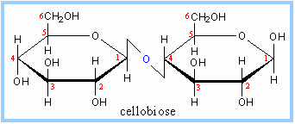
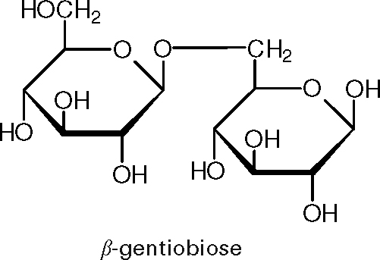

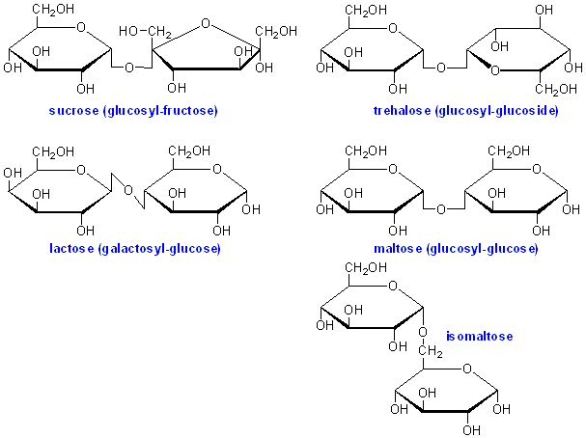

Common disaccharides
Disaccharide | Unit 1 | Unit 2 | Bond
Sucrose (table sugar, cane sugar, beet sugar, or saccharose) | Glucose | Fructose | α(1→2)β
Lactulose | Galactose | Fructose | β(1→4)
Lactose (milk sugar) | Galactose | Glucose | β(1→4)
Maltose (malt sugar) | Glucose | Glucose | α(1→4)
Trehalose | Glucose | Glucose | α(1→1)α
Cellobiose | Glucose | Glucose | β(1→4)
Chitobiose | Glucosamine | Glucosamine | β(1→4)
Maltose, cellobiose, and chitobiose are hydrolysis products of the polysaccharides starch, cellulose, and chitin, respectively.
Less common disaccharides include:^{[8]}
Disaccharide | Units | Bond
Kojibiose | two glucose monomers | α(1→2) [9]
Nigerose | two glucose monomers | α(1→3)
Isomaltose | two glucose monomers | α(1→6)
β,β-Trehalose | two glucose monomers | β(1→1)β
α,β-Trehalose | two glucose monomers | α(1→1)β[10]
Sophorose | two glucose monomers | β(1→2)
Laminaribiose | two glucose monomers | β(1→3)
Gentiobiose | two glucose monomers | β(1→6)
Turanose | a glucose monomer and a fructose monomer | α(1→3)
Maltulose | a glucose monomer and a fructose monomer | α(1→4)
Palatinose | a glucose monomer and a fructose monomer | α(1→6)
Gentiobiulose | a glucose monomer and a fructose monomer | β(1→6)
Mannobiose | two mannose monomers | either α(1→2), α(1→3), α(1→4), or α(1→6)
Melibiose | a galactose monomer and a glucose monomer | α(1→6)
Melibiulose | a galactose monomer and a fructose monomer | α(1→6)
Rutinose | a rhamnose monomer and a glucose monomer | α(1→6)
Rutinulose | a rhamnose monomer and a fructose monomer | β(1→6)
Xylobiose | two xylopyranose monomers | β(1→4)

Trisaccharide | Unit 1 | Bond | Unit 2 | Bond | Unit 3
Isomaltotriose | glucose | α(1→6) | glucose | α(1→6) | glucose
Nigerotriose | glucose | α(1→3) | glucose | α(1→3) | glucose
Maltotriose | glucose | α(1→4) | glucose | α(1→4) | glucose
Melezitose | glucose | α(1→2) | fructose | α(1→3) | glucose
Maltotriulose | glucose | α(1→4) | glucose | α(1→4) | fructose
Raffinose | galactose | α(1→6) | glucose | β(1→2) | fructose
Kestose | glucose | α(1↔2) | fructose | β(1←2) | fructose

